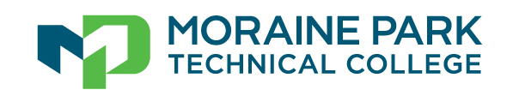
Bonnie Baerwald, MPA, CPA, President

Dear Parent:
Your student has a great opportunity to get a jump start on college and save money. Moraine Park Technical College and the high school offer dual credit courses at no charge. Dual credit courses are taught by certified high school teachers and allow your student to earn both high school and technical college credits at the same time. Please check with your school counselor to learn what courses are available.
One or more of the courses your student is already enrolled in at the high school has this option. In order to get MPTC credits your student needs to complete the registration form provided by the teacher and successfully meet the course requirements. The end result can mean a huge savings financially and in saving time. Each college credit earned is a savings of approximately $154 in tuition and fees, plus the cost of books which can cost up to $300 per book. We encourage students to plan carefully and consider the benefits and responsibilities of this commitment. The greatest value can be achieved if they select courses that relate directly to their college career aspirations.
Students who wish to earn college credit should be certain that they are ready for the rigor of college course work and motivated to successfully complete the class. Be aware all grades are posted to a student’s official college transcript. This includes a “W” indicator for course withdrawal. A grade of D, F or “W” indicator can negatively impact a student’s ability to secure federal financial aid after graduating from high school. We want students and their families to fully understand the benefits and future college impact of enrolling concurrently.
Moraine Park is excited to work in partnership with your high school to offer these opportunities. We are available to assist with career planning to help students make the most of their earned credits. If you have questions, please feel free to contact me at (920) 887-4488 or by email at arichter3@morainepark.edu.
Sincerely,
Amy Richter
Amy Richter
K-12 Partnership Coordinator

