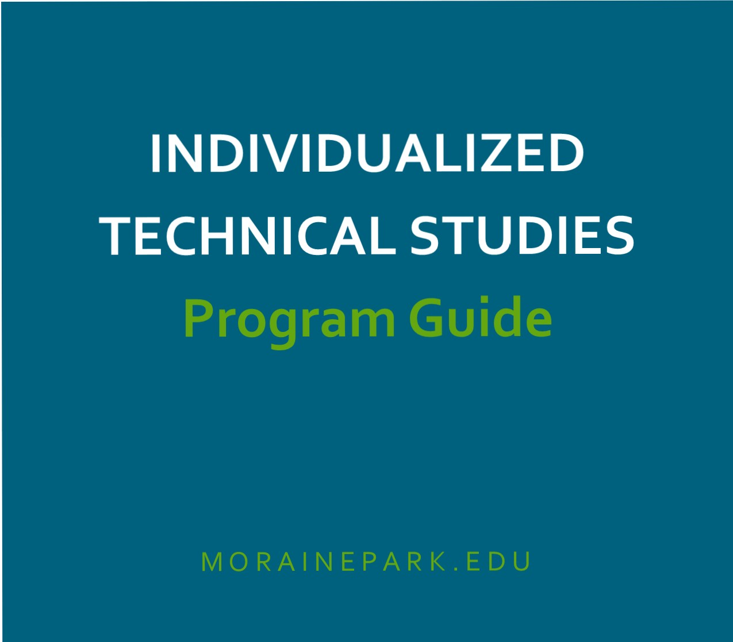

MORAINE PAR K
TECHNICAL COLLEGE

Table of Contents

Individualized Technical Studies Degree Overview 1
MPTC Core Abilities 1
Individualized Technical Studies Degree Program Process 2-3
Advanced Standing and Transfer Credit Policies 3
Individualized Technical Studies Degree Plan Self-Assessment 4
Individualized Technical Studies Degree Occupational Mentor 5
Individualized Technical Studies Degree Outcome Statement 6
Individualized Technical Studies Degree Outcome Statement (SAMPLE) 7
Individualized Technical Studies Degree Career Statement of Need 8
Individualized Technical Studies Degree Program Plan 9-10

Welcome
Welcome to Moraine Park Technical College’s Individualized Technical Studies Associate Degree. We are pleased that you are interested in pursuing your degree under this individualized program. Please review the materials in this packet to help you develop your individual program.

Introduction
Rapid changes in technology and work processes have created a growing demand for flexibility along with enhanced knowledge and skill levels in the workplace. To be productive and effective in the changing workplace, employees may need skills and knowledge drawn from a variety of traditional areas of study. The Individualized Technical Studies Degree (ITS) is a flexible program intended for individuals with specific career objectives that are not met by existing degree programs. Students work with an occupational advisor to design a unique associate degree that combines state board approved courses from two or more disciplines.

MPTC Core Abilities
Moraine Park staff, along with business and industry representatives, have identified seven skills that are essential to your success in obtaining and keeping a job. As you take courses at Moraine Park you will work towards obtaining, improving and enhancing these skills in all your courses. By helping you develop the core abilities and holding you responsible for their application, your instructors will help you achieve a successful career.
Core abilities give you an added value in the labor market, because employers prefer to hire and promote individuals who:
- Communicate Clearly
- Act Responsibly
- Work Productively
- Think Critically and Creatively
- Adapt to Change
- Demonstrate Integrity
- Work Cooperatively

- If an existing program does not meet your needs, contact the Individualized Technical Studies (ITS) Degree Advisor, Nathan Evrard at (262) 335-5729 or by email at nevrard@morainepark.edu to complete the Self-Assessment to determine if an individualized program is best for you.

- If the ITS Degree is best for you, work with the ITS Degree Advisor to begin your program planning, discuss the areas in which you are interested, and decide which combination of program areas are appropriate.

- Working with the ITS Degree Advisor, select your occupational mentor, someone who is knowledgeable about the type of occupation you have selected. The occupational mentor works in that occupation or supervises people in the type of position for which you are preparing.

- Working with your occupational mentor, complete your Career Outcome Statements
and your Statement of Need for an ITS Degree.
  - Once both are completed, submit to the ITS Degree Advisor for review. Revise these statements if necessary.

- Work with the ITS Degree Advisor to complete a Program Plan listing the courses needed for your ITS Associate Degree.

- Prepare your Portfolio and submit it to the ITS Degree Advisor for review by the MPTC ITS Associate Degree Committee. Your portfolio must contain the following documents:
  - Self-Assessment
  - Occupational Mentor
  - Career Outcome Statement
  - Statement of Need
  - Program Plan
  - A list of courses you wish to advance stand based on prior work experience, course work or non-collegiate training and include:
    - Transcripts/diplomas/certificates/licenses/degrees
    - Military experience and/or training verification
    - Samples of work/projects/picture of products, etc., if applicable

- The MPTC ITS Associate Degree Committee will review your materials and either approve or disapprove your program. Typically, portfolios submitted by April 1 will be reviewed by April 15 and portfolios received by October 1 will be reviewed by October 15.

- Upon approval, unless you are already enrolled at MPTC, complete the MPTC application process. Financial aid or veterans benefits are available for this unique program.

- Meet with your ITS Degree Advisor and your occupational mentor at least once per semester to review your progression toward degree completion.

- During the last semester, complete a Graduation Form and submit it to registration.

Credit for Prior Learning Policies
Students may be eligible for credit based on proficiency gained through work or military experience/training, proficiency examinations, courses completed at accredited postsecondary institutions, non-collegiate training, or other prior learning experiences.
For more information, visit morainepark.edu/CPL
A minimum of 25% of the total program credits (with a minimum of 12 credits in the technical discipline/occupation core) must be earned at Moraine Park Technical College.

Fill out this checklist to determine if an Individualized Technical Studies Associate Degree Program is the best learning option for you.

Check yes or no for each of the following statements: Yes No

1. I have three to five years of employment experience. | ☐ | ☐
2. I can list my employment strengths. | ☐ | ☐
3. I know the areas in which I need to improve or acquire new skills. | ☐ | ☐
4. I know what kind of work gives me personal satisfaction. | ☐ | ☐
5. I know what kind of work I would like to be doing five years from now. | ☐ | ☐
6. I have a plan for preparing for the work I want to be doing in five years. | ☐ | ☐
7. I have thoroughly explored existing MPTC programs and find none that meet my specific career goals. | ☐ | ☐
8. I am willing to budget my time and prioritize activities in order to be a successful student. | ☐ | ☐
9. I meet the reading, math, and language writing requirements for college entrance. | ☐ | ☐
10. I have a good relationship with an employer who may serve as an occupational mentor for my Individualized Technical Studies Associate Degree. | ☐ | ☐

If you were able to check the “Yes” column for all or most of the above statements, you are an excellent candidate for the Individualized Technical Studies Associate Degree. Proceed to prepare your portfolio for consideration by the MPTC Individualized Technical Studies Associate Degree Committee.

The occupational mentor is valuable individual who will help in guiding your Individualized Technical Studies Associate Degree program. Your occupational mentor may be your employer or even someone with whom you are acquainted who is familiar with the career you are selecting and needs to be aware of the employment demands of that career.
The occupational mentor performs the following tasks in developing your degree plan:
- Helps you prepare and approves your Career Outcome Statement
- Assists you in preparing and approving your Statement of Need for the Individualized Program of Study that makes up your Individualized Technical Studies Associate Degree.
- May be called upon by your ITS Degree Advisor to provide program planning advice.
- Provides guidance for you through semi-annual meetings as you progress in your program.

Student Name: Click here to enter text. Career Goal: Click here to enter text. Occupational Mentor Name: Click here to enter text. Occupational Mentor Employer: Click here to enter text. Job Title: Click here to enter text. Phone: Click here to enter text. E-mail: Click here to enter text.
Please list your occupational experience and education that is related to the student’s career goal and attach a resume or current job description:
Click here to enter text.

Mentor Signature: Date:

Student Name: Date: Career Goal:

After completion of this program, I will be able to:
1.
2.
3.
4.

5.
6.
7.
8.
9.
10.
11.
12.

Approval Signatures

Mentor Signature: Date:

Student Signature: Date:

Student Name: Jeffrey Sample Date: 1/5/2017 Career Goal: Crop Production Specialist

After completion of this program, I will be able to:
- Understand principles of soil fertility.
- Integrate information about pest management and plant identification to assist customers with decisions about product use.
- Utilize information about vegetable crops in Wisconsin and the total production process of those crops (seeds, fertilizers, herbicides) to assist customers with product decisions.
- Qualify for a commercial applicators certificate.
- Be employed as a certified crop advisor.
- Interpret finical reports and other financial information, such as taxes, borrowing, and discounts.
- Understand the language of business and be able to communicate appropriately in the business community.
- Possess computer skills for developing and using spreadsheet, word processing and working with databases.
- Understand the financial aspects of small business, such as loans and investments, etc.

Approval Signatures

Mentor Signature: Sarah Advisor Date: 11/15/16

Student Signature: Jeffery Sample Date: 11/16/16

Student Name: Date: Career Goal:

Your Statement of Need explains why you need to develop an Individualized Technical Studies degree to meet your career goals. Please explain why your goals cannot be met by existing Moraine Park Technical College associate degree programs.

Approval Signatures

Mentor Signature: Date:

Student Signature: Date:

Student Name: ID: N
(Last) (First) (MI)

Effective date of curriculum: Credits required for this program:

GENERAL EDUCATION - 18 credits

Communications – 6 credits (minimum) |  | Course # |  | Credits
Title
Social Science – 3 credits (minimum) |  | Course # |  | Credits
Title
Behavioral Science – 3 credits (minimum) |  | Course # |  | Credits
Title
Mathematics or Science – 3 credits (minimum) |  | Course # |  | Credits
Title
Additional Gen Ed – 3 credits (from any category) |  | Course # |  | Credits
Title

Total credits from section A:

Individualized Technical Studies Core - 42 credits
Program Emphasis (minimum of 20 credits from one area)
Course Title Course # Credits

Total credits from section B: Total credits from section A&B:

